1. What is agile model
2. What is sprint
   1. Scrum
   2. Product backlog
   3. Scrum backlog
3. Jira is a tool to manage the project: -Jira is a project management tool that helps teams plan, track, and release software. It can also be used for other purposes, such as marketing, IT, design, etc
4. What is devops?

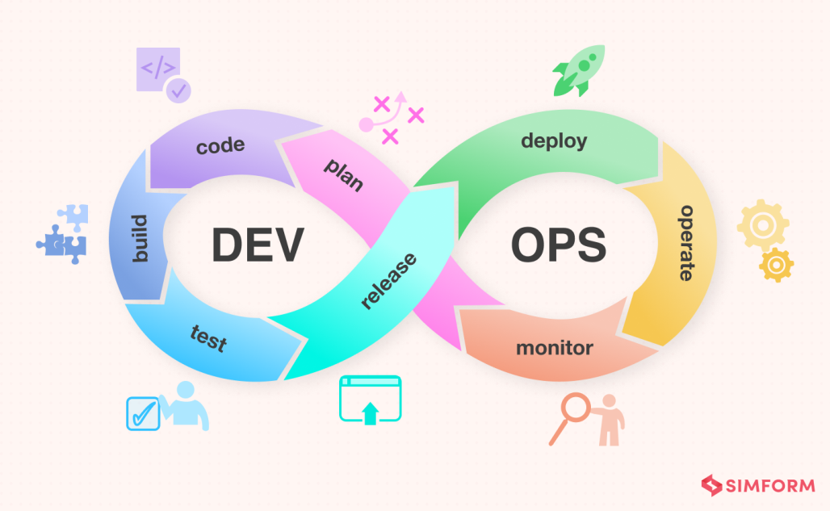

3 main stages of devops:

(i)Source code management (git tool)

(ii)Continuous integration (jenkins tool)

(iii)Continuous delivery/ continuous deployment

